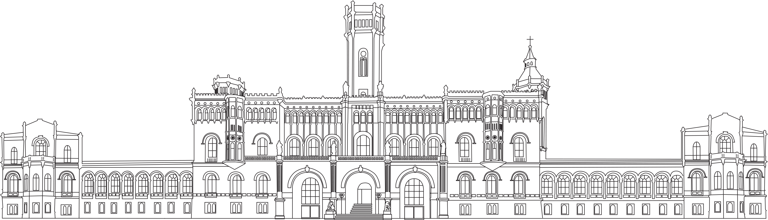
Leibniz Universität Hannover
Fakultät für Elektrotechnik und Informatik
Fachgebiet Mensch-Computer-Interaktion
ambient notifications for
a shape-changing display
Abschlussarbeit zur Erlangung des
akademischen Grades Bachelor of Science
vorgelegt von
Christian Althaus
2926940
Februar 2018

 | Erstprüfer:  Zweitprüfer:  Betreuer: | Prof. Dr. Michael Rohs  Prof. Dr. Kurt Schneider  Tim Dünte, M.Sc.

Zusammenfassung
Dieses Dokument soll einige Hilfestellungen zu Aufbau, Gestaltung und Inhalt Ihrer Abschlussarbeit geben. Für Bachelor- und Masterarbeiten am Fachgebiet Mensch-Computer-Interaktion existieren Formatvorlagen für Word und LATEX. An dieser Stelle muss eine Zusammenfassung Ihrer Abschlussarbeit auf Deutsch stehen, die maximal eine halbe Seite lang ist.

Quellen:
Die Hinweise in dieser Formatvorlage basieren auf einer von Prof. Dr. Müller-Clostermann, Institut für Informatik und Wirtschaftsinformatik, Universität Duisburg-Essen, herausgegebenen Formatvorlage, welche wiederum auf einer Formatvorlage für Diplomarbeiten an der TU Darmstadt aus der Arbeitsgruppe von Prof. Dr. Mühlhäuser basiert.
Abstract
In addition to the German Zusammenfassung, an English abstract is required as well. Authors writing their thesis in English should swap the positions of Abstract and Zusammenfassung.
Danksagung
This part is not necessary but some people might like to thank their reviewers, family, and other people who are supporting their work.

Inhaltsverzeichnis
1 Introduction 2
2 related Work 2
2.1 effects of Color on Emotions 2
2.2 DEFINTION 8
2.3 Classification of shape-changing Interfaces 8
2.4 SHAPe-Changing Interfaces 11
3 concept 21
4 development/implementation 23
5 USER STUDY 25
6 RESULTS 27
Literaturverzeichnis 29
Abbildungsverzeichnis 33
Tabellenverzeichnis 38

Introduction

related Work
In this chapter different kinds of shape-changing interfaces respectively works are presented to illustrate the potential and usage of this technology.
First, the effects of colors on emotions are approached, followed by definitions and a classification of shape-changing interfaces. Then works and projects are introduced.

effects of Color on Emotions
In this section, works regarding the effects of colors on emotions are reviewed, since the MovingBars use colour LED lights to convey information to an human user. Thus, ambient notifications can purposeful be provided with colour light to support a specific, intended atmosphere respectively emotion.
Valdez and Mehrabian (1994) investigated the effect of color stimuli on human emotions. While previous works in this topic mostly used vague description of colour and emotion, they tried a more systematic and standardized approach. First they use the standardized Munsell color system, which retains the perceived color distance of human color vision within the system.
A color can be described “in terms of hue ( i.e. wavelength ), brightness or value ( i.e. black-to-white quality ) and saturation or chroma( i.e. purity [...] )”. They describe the impact of each of this color property independedly on emotions.
To describe emotions most correctly, they used the PAD model, which stands for pleasure, arousal and dominance. The PAD factors are “analogues of the Evaluation, Activity and Potency factors which [...] may be characterized as the lowest common denominator of cognitive response”. With these factors emotions can be described, for example bold ( .44, .61, .66 ) or distressed ( -.61, .28, -.36 ), which has low pleasure and dominance values, while arousal is higher. An approximate mapping of emotions to PAD values the authors derived from ratings of 240 emotional states (see Table 1).

P | A | D | Emotions
+ | + | + | admired, bold, creative, powerful, vigorous
+ | + | – | amazed, awed, fascinated, impressed, infatuated
+ | – | + | comfortable, leisurely, relaxed, satisfied, unperturbed
+ | – | – | consoled, docile, protected, sleepy, tranquilized
– | + | + | antagonistic, belligerent, cruel, hateful, hostile
– | + | – | bewildered, distressed, humiliated, in pain, upset
– | – | + | disdainful, indifferent, selfish-uninterested, uncaring, unconcerned
– | – | – | bored, depressed, dull, lonely, sad
Table 1: PAD scores for different emotions

The studies among others include persons, which should look at a colored paper and then complete a questionarie to record their emotions. Ten colors respectively hues were illustrated, with differences in brightness and saturation. Hue, brightness and saturation are the independent and pleasure, arousal and dominace are the dependent variables. With linear and nonlinear regression analyses the authors computed graphs, which should explain the correlate between these variables.
While the independent variable saturation has no significant square amount of the nonlinear function, three linear equations yield an impression of the correlations.
(1) Pleasure = .69 Brightness + .22 Saturation (2) Arousal = -.31 Brightness + .60 Saturation (3) Dominance = -.76 Brightness + .32 Saturation
Equation 1 indicates, that brighter and more saturates colors are more pleasant. Equation 2 and 3 shows, that less bright and more saturated colors provoke higher arousal and dominance.
The authors illustrated the effect of brightness on dominance and arousal with nonlinear functions (see Figure 1, Figure 2). For pleasure the linear correlation in Equation 1 is sufficient.
Figure 1: Actual and predicted dominance levels for brightness
Figure 2: Actual and predicted arousal levels for brightness
These findings indicate, that the provoked emotion is not only dependent on hue, but also strong correlates with brightness and saturation. The authors clarify the commom error, that for example in many experiments the color red is often associated with arousing emotions, while in fact the high saturation is the reason.
The effects of hue respectively wavelength on pleasure is shown in Figure 3 (See Appendix for arousal and dominance).
Figure 3. Mean pleasure level plotted against wavelength

Light Patterns
In this section light patterns will be presented, in order to illustrate informational states of a device.
Harrison et al. (2012) investigated light patterns of a single point light in terms of enhancing the design space of devices, which use LED’s to convey information. Light Patterns are generated by varying the light intensity over time. The kinds of information, that a device intends to convey to a user, the authors called informational states. Informational states, for example, can be the boot process or transferring data of a device. The authors collected various of these states by a survey and distributed them in five categories, because some states were highly correlated. The categories are Notification, Active, Unable, Low-Energy State and Turning On (see Table 2).

Category | Informational States
Notification | The device has an incoming call.  …received a message.  …event or scheduled item.
Active | …transmitting or receiving data.  …thinking, computing, or processing.  …active, monitoring, … or progressing.
Unable | …unable to connect. …unable to accept user input or commands
Low-Energy State | …low battery.  …sleeping, suspended, or hibernating.
Turning On | …turning on, booting, or warming up.
Table 2: High-level categories

Within the survey they also collected 24 feasible light behaviours respectively light patterns, which were known by the patrticipants (see Fehler! Verweisquelle konnte nicht gefunden werden.).

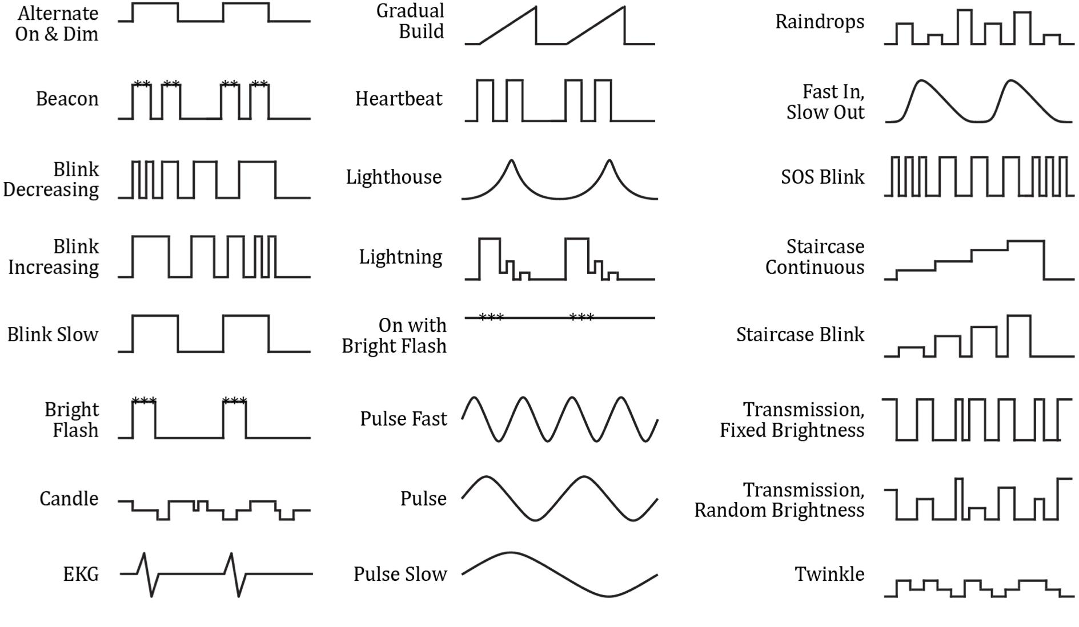
Figure 4: Light patterns

In an additional survey, persons should rate how strongly every light pattern represents each of the five informational states. A five-point likert scale was used for the ratings( see Fehler! Verweisquelle konnte nicht gefunden werden., Figure 6: Ratings of light patterns for the active state and Appendix : Figure 24, Figure 25).

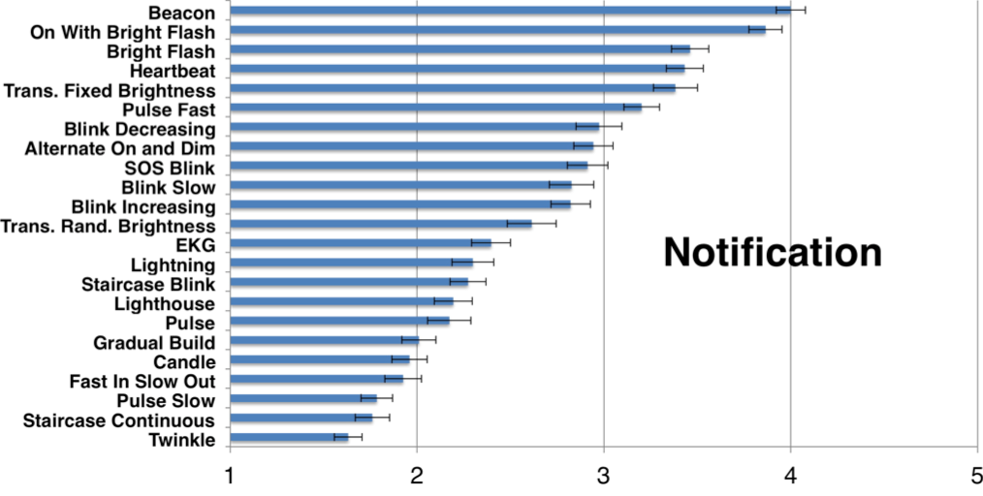
Figure 5: Ratings of light patterns for notifications

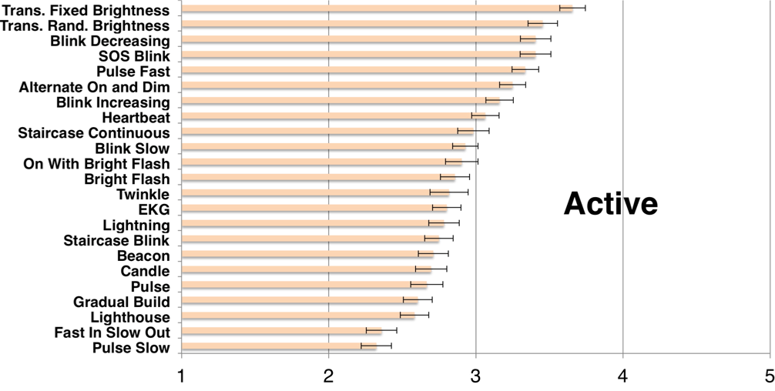
They mention, that a good light pattern should have a strong interpretation, indicated by a high Likert rating. Furthermore it should be iconic, also represent one information state strongly in comparion to others. With these criterias, they choose eight recommendable light patterns. (//create figure)
Figure 6: Ratings of light patterns for the active state

DEFINTION
In this section the term shape-changing interface respectively display is explained by reference to different works.
Poupyrev et al. (2007) define shape displays as displays, which can „directly create 3D physical shape“. Hardy et al. (2015) describe a actuated shape-changing displays as a display, that „transform our interactions with technology by exploiting perceived affordances inherent in physical form“.
/* TODO: Definition Ambient Interface ?!*/

Classification of shape-changing Interfaces
First a work is reviewed, which gives an overview of the foundations of physical shape change. This should allow a classification of shape-changing interfaces.
Rasmussen et al. (2012) give an classification of the design space regarding shape-changing interfaces. They conclude, that there’re four important aspects of shape change: the change in shape, the dynamics of change, the interaction and its purpose.

TYPES OF CHANGE IN SHAPE
The authors distinguish between eight types of change in shape: orientation, form, volume, texture, viscosity, spatiality, adding/subtracting and permeability (see Figure 7). Following a short explanation of the terms.
Orientation distorts „the original shape through rotations or changes in direction, while preserving the recognizability of the original form“.
Form retains its original volume, while ”changing its overall form“.
Volume whereas modifies size of an object, but maintain the overall form.
Texture changes the surface properties of an object. This adds “visual and tactile properties without affecting the overall form“.
Viscosity whereas can be viewed as a specialization of texture. Changes in viscosity „can result in both physical shape changes and in the illusion of shape change“.
Spatiality changes the spatial position of objects. This transformation properly speaking doesn’t modify the physical shape of objects, but through repositioning it evokes a visual illusion.
These transformations are referred to topological equivalent functions respectively homeomorphism. „Two spaces are topologically equivalent if they can be continuously stretched and deformed into another without cutting or joining distinct parts“ (Marcelo Coelho & Zigelbaum, 2011). The next two transformations are not topological equivalent.
Figure 7: Types of changes in shape
Adding or Subtracting is described as „transformations that unite or divide elements, while being able to return to the initial shape or shapes“.
Permeability changes are defined “by transformations, where the shape is perforated, but able to return to its initial shape “.

TYPES OF TRANSFORMATIONS
The shape changes before describe a transformation referred to initial and end state. However, it’s also important to define classification parameters between these states. Rasmussen et al. (2012) distinguish between kinetic and expressive parameters. Kinetic parameters should outline the physical changes like acceleration, speed and frequency. Based on that, the expressive parameters should reflect the perception of the kinetic parameters.
Kinetic parameters are velocity, path, direction and space.
Velocity describes “the speed, acceleration, tempo, vibration and frequency of an object’s movement“.
Path illustrates the movement pattern, which can be linear/curved, continuous/intermittent, smooth/jerky or pattern/random.
Direction describes „the direction in which the object moves “and can be up/down, left/right or forward/backward.
Space describes „the use of space by the interface, including scale change and form change “.
Expressive parameters are divided into association and adjectives.
Association should answer the question, how much an interface is perceived as nature-like. This is because many works try to reproduce nature-like motions or properties in the interfaces. Therefore, the interface can be perceived as organic or mechanical.
Adjectives describe the qualities and emotional/personal traits, which are assigned to the interface by the user. Qualities are for example soft, pleasant or peaceful. Personal traits include emotions like happy, sad or angry.
The authors mention, that it’s important to prove the ascribed, subjective expressive parameters of the developers with user studies. They critize, that it’s usually rare to see user studies, who actually test the shape-changing interface.

INTERACTION
This aspect of shape change defines the interaction between the interface and the user. Shape change can be used as input and/or output. Thus, the authors refer to three types of interaction: no interaction, indirect interaction and direct interaction (see Figure 8).
Figure 8: Interaction between the interface and the user
No interaction means, that the shape is only used as output. The user doesn’t interact with the interface.
Indirect interaction like no interaction uses only shape-changing output, but additional include implict input. The authors define input as implict, when “users may not realize that their actions are being used as input“. Examples for implict input can be environmental sensations such as sound, movement and perhaps also personal profiles of the user.
Direct Interaction implies that there’s both input and output. The authors describe this as action and reaction or input and output. Whereas the first term refers to direct feedback, the second refers to not directly related feedback. The output can also be displayed on a remote interface. This can for example allow real-time user communication.

PURPOSE OF SHAPE CHANGE
The purpose or aims of a shape-changing interfaces can be divided into four sub-categories. Namely functional aims, hedonic aims, explorative and toolkits. The authors mention that an interface can have more than one purpose, but for mapping the design space of shape-changing interfaces each of the purposes is discussed separately.
Functional aims for shape change describe the purpose to communicate information, model dynamic affordances and/or give haptic feedback. Furthermore, the authors name the practical and construction purpose.
Hedonic aims should represent the non-instrumental goals like aesthetics, emotion and/or stimulation.
Explorative aims should illustrate the technical aspect of shape change and increase “the understanding of the materials involved in shape change“. For example, through usage of new shape-changing materials in simplistic prototypes.
Toolkits are used for programming shape change through composing several parts.

SHAPe-Changing Interfaces
In this chapter different works will be presented to illustrate the usage of shape-changing interfaces.

FIELD OF ART

Scenarios for shape-changing displays among can be found in the field of art. These works are primarily used for hedonic aims. An advantage is, that 3D shapes and real physical forms are clearly more accessible for especially non-technical people.
The Source for example is an installation in the Londoner Stock Exchange from an artists group called greyworld (2015, see Figure 7). It’s build of balls representing pixels, that are arranged in a 9x9x9 Cube and attached to metal cables. Within a height of 32 meters the balls can move and form 3D shapes. The installation is used to generate forms of live data to visualize the forces in financial markets. Additional it is used to write messages and visualize forms like an uprising sun in the morning.

Another art project is Protrude, Flow (Kodama & Takeno, 2001) which uses magnetic fluid and electromagnets to form shapes. Besides a microphone can capture surrounding sounds, which influence the forms of the fluid shape. Then there’s Aegis Hyposurface (Goulthorpe, 2001), which is a 10 meters wide and 3 meters high wall. It consists of interconnected metal plates, that are actuated by pneumatic pistons. Dependent on environmental stimuli like movement, sound or light, the wall changes its shape based on real-time calculations (see Figure 9).
The concept of representing digital information on moving objects, like in The Source, is quite similar to the Moving Bars, worked with in this thesis. Both can move horizontal to visualize trends respectively properties of the data. Although the Moving Bars can’t model 3D object, they use color LED’s for information representation. Also, the main idea differs, because The Source is intended to show the data in an abstract way given an impression of the flow of the data, rather than showing their meaning.

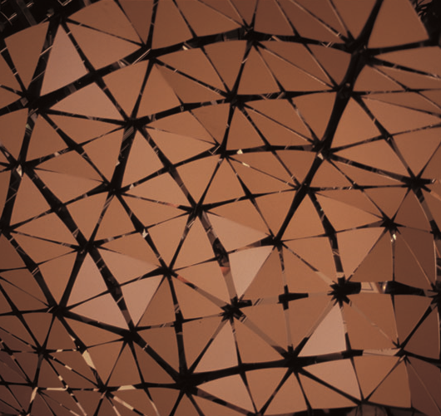
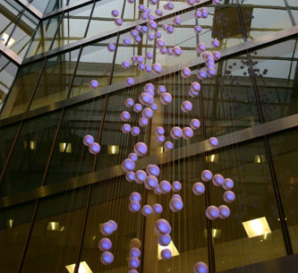
In contrast to the MovingBars, Protrude-Flow and Aegis Hyposurface show a representation of environmental information, rather than inform people about external digital information.
Figure 9: Aegis Hyposurface
Figure 10: The Source

FIELD OF 3D SHAPE DISPLAYS

Another application area of shape-changing interfaces are displays, which are based on a pin architecture. Commonly they’re composed of an array of pins, which can modify their height to form 3D shapes.
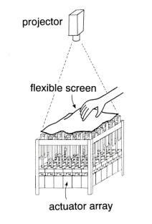
Iwata et al. (2001) developed such a display named FEELEX, which can display simple shapes. It’s based on an actuator array, which is encased with an elastic rubber, nylon surface. Graphics are projected onto the screen and interaction is possible due to a force sensor on every linear respectively height-adjustable actuator (see Figure 12).

Furthermore there’s Lumen (Poupyrev, Nashida, Maruyama, Rekimoto, & Yamaji, 2004), which is like FEELEX based on an actuator array, but without a deformable layer. There’re rods, which can adjust the height of the rounded, color-changing pixels on the top. Every pixel has a capacitive touch sensor, enable interaction with the shapes on the display (see Figure 11).
Figure 11: Lumen
Figure 12: FEELEX setup

Poupyrev et al. (2007) mention, that the main problem with these shape-changing displays is their low resolution. To get realistic textures and effects „the pixel size must shrink at the very least to 1mm“. The authors furthermore suggest to extend the traditional RGB model with the attribute of height. They call it RGBH graphics and mention, that „it can be viewed as the next step in the evolution of a pixel“. They suggest a design property for these RGBH displays, distinguish between synchronous and asynchronous modes. These modes should represent the relation between shape and image. In the synchronous mode „the shape extends the graphics, it adds a third dimension to flat images“. The asynchronous mode distinguishes between shape and image, so „shape and image are independent from each other and serve different purposes“.
Follmer at al. (2013) developed an display called inFORM, which uses a 30x30 pin array to model shapes, an camera to sense haptic input and a projector to provide graphics (see Figure 14). This display has the highest resolution respectively density of pins within the investigated works. The authors showed how this display can be used for 3D model manipulation on the screen. Different tools, like in a drawing program, can be chosen by putting a ball in corresponding wells and browsing/scaling can be simulated through moving the ball in a appearing slot (see Figure 13). It’s also possible to deform the model by modify the pins by hand.

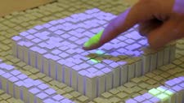
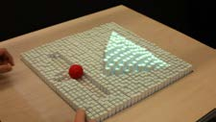
These works focus on extending an 2D display with an additional physical height dimension to visualize objects. The Moving Bar’s aren’t supposed to rendering 3D objects, but should show information trends by adjusting their height.
Figure 13: Browsing
Figure 14: Interaction

FIELD OF TOOLKITS

Hardy et al. (2015) developed what they called ShapeClip to build a shape-changing display. Their goal was to shorten the time of the prototyping process with a shape-changing display and lower the complexity to design it. Therefor it was necessary to make the building parts easy to use for people without the specific technical and programmable knowledge. A ShapeClip can be placed on any display and tracks the change of the screen brightness by using Light Dependent Resistors (LDRs). Dependent on that, the clip modifies its height and output color. Furthermore, touch events can be forwarded from the top of the ShapeClip to the display. ShapeClips can be arranged in an array. With this technology, there can easily be made a shape-changing display, for example a sound equalizer (see Figure 16) or a terrain map. Even with a single ShapeClip, trends of data can be visualized by moving it over the display (see Figure 15).

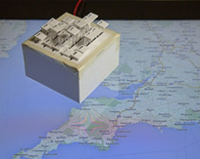
While Hardy et al. (2015) use physical information as input and output (touch, light), this thesis works with a moving bar, which visualizes data from a computer system. However, the concept of the z-actuation is also used by the moving bar.
Figure 15: Reveal Trends
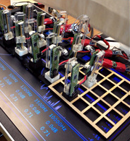
Figure 16: Sound Equalizer

FIELD OF AMBIENT NOTIFICATIONS

Pinwheels (Ishii, Ren, & Frei, 2001) is an ambient display, which can illustrate the flow of digital information through „subtle changes in movement and sound“. The authors mapped different information onto the pinwheel, for instance the traffic at a subway station captured by a camera or activities in e-mail exchanges.
Water Lamp (Dahley, Wisneski, & Ishii, 1998) is an ambient fixture, which uses water ripples projected by light to show digital information. The water ripples are evoked by computer-controlled magnets tapping the water surface. The authors mention, they “envisioned that ‚bits‘ (digital information) falling from cyberspace could create physical water ripples“.
Shade Pixel (Kim & Lee, 2008) is an ambient display, which uses only shade to illustrate pixel-graphics. The display is enclosed with a deformable spandex skin, which is attached to a frame with an array of 7x11 holes. In each hole an iron core is attached to the surface layer, which can be adjusted in height by a magnet. This allows to create a sunken-like relief. Thereby graphics can be displayed on the white surface using only the visual differences in shade. Shade Pixel doesn’t produce visual noise, like traditional light emissive displays. The display “can be embedded into the surfaces of everyday products such as home appliances, furniture, or other aspects of the everyday environment as an ambient display“.

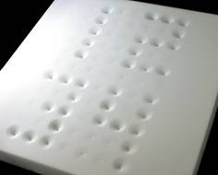
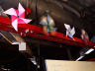
Like these works, the Moving Bars stay in background and convey information through light, in common with WaterLamp, allowing the user to focus his main attention to other things. With height movement and light patterns, different scenarios can be mapped onto the LED’s. The above works whereas don’t use color light panels.
Figure 17: Watch
Figure 18: Array of Pinwheels

FIELD OF EVERYDAY GRASPABLE OBJECTS

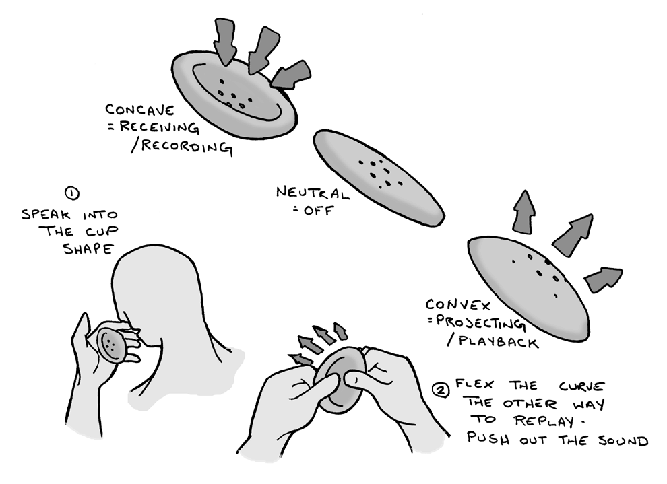
Coelho and Zigelbaum (2011) build the audio recorder respectively player SpeakCup, which uses shape change for direct interaction. It’s a hand-sized silicone disk, allowing to capture and release sound by pressing it into a concave or convex form. An embedded flex sensor is used to detect the deformation. Flashing Red LED’s indicate the recording mode and the system is shut down by flexing it to the flat position.
Figure 19: SpeakCup
Shape change is also used for interactive feedback in mobile phones. Hemmert et al. (2010a) developed a box, which can be attached to a mobile phone. This box allows to modify the tapering between the front and backplane of this phone construction. The authors present some applications enable interactive feedback or user notification. In mobile photo browsing the position of the current photo in an album is indicated by the shift of the backplane to the right or left, while „the phone is held in landscape format“. Another application is showing the progress of a download.
The authors also developed another box, which uses weight-shift to „support mobile interactions“ (2010b). In the box a servo motor is used to rotate a weight, creates a weight shift in the overall construction. This is used to tactile illustrate a file download or the battery status.

FIELD OF CONCEPTUAL INTERFACES

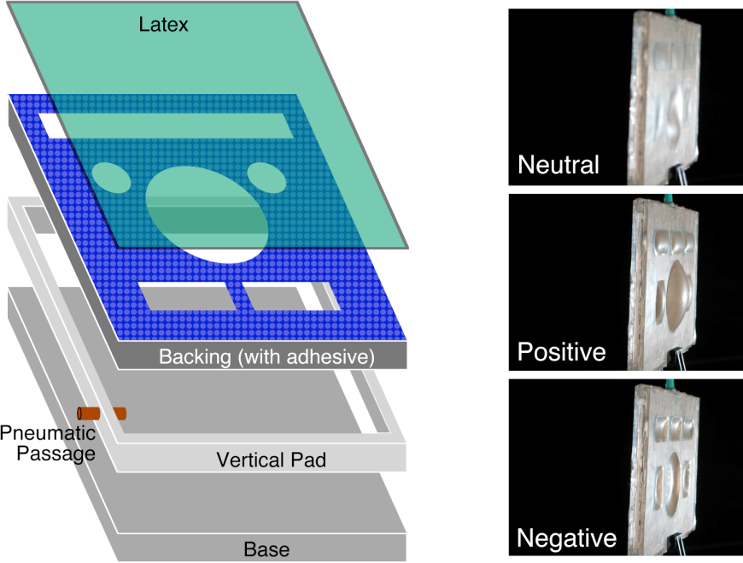
Harrison et al. (2009) developed a method to create changeable buttons on a visual display. They use pneumatic actuation respectively air pressure to shape buttons into the surface latex layer. Previously the shape of the buttons has to be cut out of a solid backing layer. With fan-based pumps negative and positive pressure is created inside the frame respectively single or multiple chambers, resulting in concave and convex button shapes. The display provides graphics by rear projection and multitouch input, also because the display is made of transparent and translucent materials. This prevents occlusion while user interaction. This technique is “offering some of the flexibility of touch screens, while retaining the beneficial tactile properties of physical interfaces“. Within a user study the authors figured out, that the attention to locate and press a button (secondary task) on the mentioned interface is at the same level as physical buttons, while performing a primarily task. On the other hand, the authors found out, that flat displays needed much more visual attention than the other shape displays.
Figure 20: Dynamic Buttons

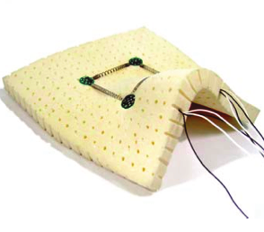
Surflex (M. Coelho, Ishii, & Maes, 2008) is a programmable and shape-changing surface, made out of foam and shape-memory alloys. It’s intended for “the design and visualization of physical forms“. Circuit boards and shape-memory alloys (SMA), which are made out of nickel and titanium, are embedded in the 1“ foam. Through electrical heating the SMA wire deforms, allowing the construction to change its form. The authors envision, that this can be used for “real-time computer modeling of objects and spaces, and the construction of adaptable interfaces“.
Figure 21: Surflex

/* TODO: Ambient light devices (commercial) */

concept

development/implementation

USER STUDY

RESULTS

APPENDIX

RELAted Work

Effects of Color on Emotions – Functions
Figure 22: Mean arousal level plotted against wavelength

Figure 23: Mean dominance level plotted against wavelength

Light Patterns – Figures

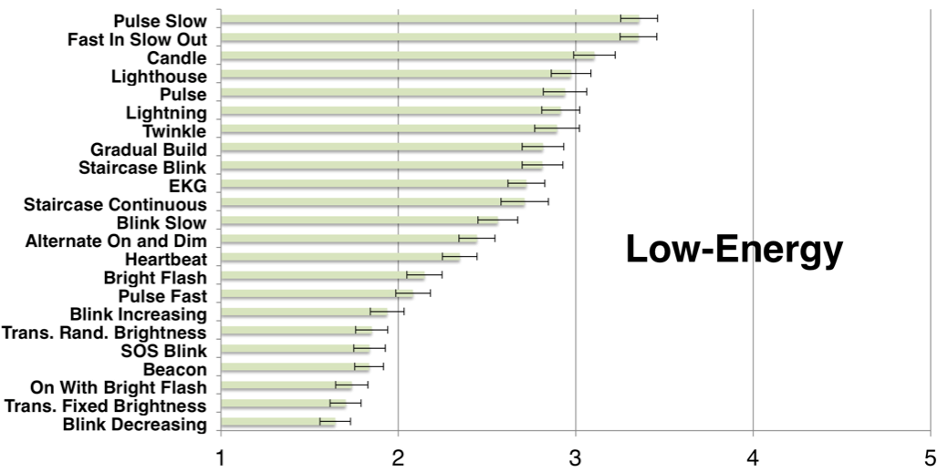
Figure 24: Ratings of light patterns for the low-energy state

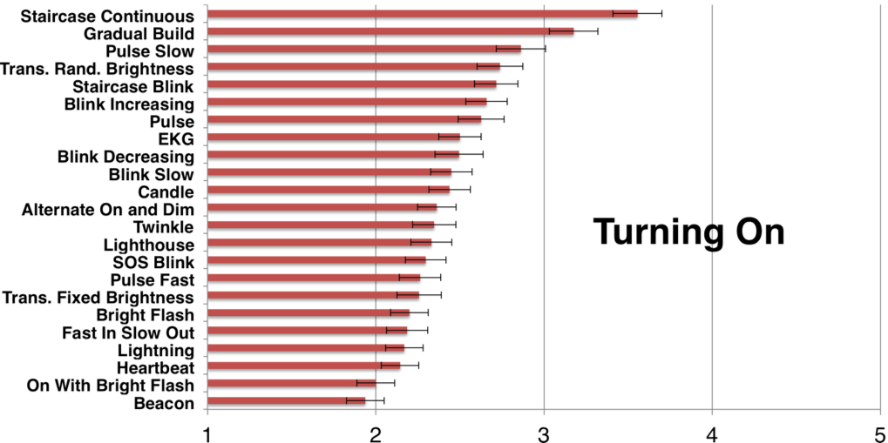
Figure 25: Ratings of light patterns for the turning on state

LIST OF TABLES
Table 1: PAD scores for different emotions 3

LIST OF FIGURES

Figure 1: Actual and predicted dominance levels for brightness 4
Figure 2: Actual and predicted arousal levels for brightness 4
Figure 3. Mean pleasure level plotted against wavelength 4
Figure 4: Light patterns 6
Figure 5: Ratings of light patterns for notifications 7
Figure 6: Ratings of light patterns for the active state 7
Figure 7: Aegis Hyposurface 12
Figure 8: The Source 12
Figure 10: Lumen 13
Figure 9: FEELEX setup 13
Figure 12: Browsing 14
Figure 11: Interaction 14
Figure 14: Reveal Trends 15
Figure 13: Sound Equalizer 15
Figure 15: Watch 16
Figure 16: Array of Pinwheels 16
Figure 17: SpeakCup 17
Figure 18: Dynamic Buttons 18
Figure 19: Surflex 18
Figure 20: Mean arousal level plotted against wavelength 29
Figure 21: Mean dominance level plotted against wavelength 30
Figure 22: Ratings of light patterns for the low-energy state 31
Figure 23: Ratings of light patterns for the turning on state 31

Literaturverzeichnis
Coelho, M., Ishii, H., & Maes, P. (2008). Surflex: a programmable surface for the design of tangible interfaces. CHI ’08 Extended Abstracts on Human Factors in Computing Systems, 3429–3434. https://doi.org/http://doi.acm.org/10.1145/1358628.1358869
Coelho, M., & Zigelbaum, J. (2011). Shape-changing interfaces. Personal and Ubiquitous Computing, 15(2), 161–173. https://doi.org/10.1007/s00779-010-0311-y
Dahley, A., Wisneski, C., & Ishii, H. (1998). Water Lamp and Pinwheels : Ambient Projection Digital Information into Architectural Space. CHI 98 Conference Summary on Human Factors in Computing Systems, (April), 269–270. https://doi.org/10.1145/286498.286750
Follmer, S., Leithinger, D., Olwal, A., Hogge, A., & Ishii, H. (2013). inFORM: Dynamic Physical Affordances and Constraints through Shape and Object Actuation. Proceedings of the 26th Annual ACM Symposium on User Interface Software and Technology - UIST ’13, 417–426. https://doi.org/10.1145/2501988.2502032
Goulthorpe, M. (2001). Aegis Hyposurface. Retrieved from https://mcburry.net/aegis-hyposurface/
Hardy, J., Weichel, C., Taher, F., Vidler, J., & Alexander, J. (2015). ShapeClip: Towards Rapid Prototyping with Shape-Changing Displays for Designers. Proceedings of the ACM CHI’15 Conference on Human Factors in Computing Systems, 1, 19–28. https://doi.org/10.1145/2702123.2702599
Harrison, C., Horstman, J., Hsieh, G., & Hudson, S. (2012). Unlocking the expressivity of point lights. Proceedings of the 2012 ACM Annual Conference on Human Factors in Computing Systems - CHI ’12, 1683–1692. https://doi.org/10.1145/2207676.2208296
Harrison, C., & Hudson, S. E. (2009). Providing Dynamically Changeable Physical Buttons on a Visual Display. Proceedings of the 27th International Conference on Human Factors in Computing Systems - CHI 09, 299–308. https://doi.org/10.1145/1518701.1518749
Hemmert, F., Hamann, S., Laboratories, D. T., Zeipelt, J., & Joost, G. (2010a). Shape-Changing Mobiles : Tapering in Two-Dimensional Deformational Displays in Mobile Phones. Proceedings of the 28th of the International Conference Extended Abstracts on Human Factors in Computing Systems CHI EA 10, 3075–3079. https://doi.org/http://doi.acm.org/10.1145/1753846.1753920
Hemmert, F., Hamann, S., Laboratories, D. T., Zeipelt, J., & Joost, G. (2010b). Weight-Shifting Mobiles : Two-Dimensional Gravitational Displays in Mobile Phones. Proc. CHI, 3087–3091. https://doi.org/10.1145/1753846.1753922
Ishii, H., Ren, S., & Frei, P. (2001). Pinwheels: visualizing information flow in an architectural space. CHI ’01 Extended Abstracts on Human Factors in Computing Systems, 111–112. https://doi.org/10.1145/634067.634135
Iwata, H., Yano, H., Nakaizumi, F., & Kawamura, R. (2001). Project FEELEX: Adding Haptic Surface to Graphics. Proceedings of the 28th Annual Conference on Computer Graphics and Interactive Techniques, (1), 469–476. https://doi.org/10.1145/383259.383314
Kim, H., & Lee, W. (2008). Shade Pixel. SIGGRAPH Posters, 34. https://doi.org/10.1145/1400885.1400922
Kodama, S., & Takeno, M. (2001). Sound-responsive magnetic fluid display. Human-Computer Interaction - Interact’01, (Figure 2), 737–738.
Poupyrev, I., Nashida, T., Maruyama, S., Rekimoto, J., & Yamaji, Y. (2004). Lumen. ACM SIGGRAPH 2004 Emerging Technologies on - SIGGRAPH ’04, 17. https://doi.org/10.1145/1186155.1186173
Poupyrev, I., Nashida, T., & Okabe, M. (2007). Actuation and tangible user interfaces: the Vaucanson duck, robots, and shape displays. Proceedings of TEI 2007, 205–212. https://doi.org/10.1145/1226969.1227012
Rasmussen, M. K., Pedersen, E. W., Petersen, M. G., & Hornbæk, K. (2012). Shape-Changing Interfaces: A Review of the Design Space and Open Research Questions. Proceedings of the SIGCHI Conference on Human Factors in Computing Systems (CHI ’12), 735–744. https://doi.org/10.1145/2207676.2207781
The Source. (2015). Retrieved from http://greyworld.org/archives/31
Valdez, P., & Mehrabian, A. (1994). Effects of color on emotions. Journal of Experimental Psychology: General, 123(4), 394–409. https://doi.org/10.1037/0096-3445.123.4.394

Tabellenverzeichnis
Tabelle 1. Eine aussagekräftige Tabelle. Fehler! Textmarke nicht definiert.

Eidesstattliche Erklärung
Hiermit versichere ich, dass ich die vorliegende Arbeit ohne Hilfe Dritter und nur mit den angegebenen Quellen und Hilfsmitteln angefertigt habe. Ich habe alle Stellen, die ich aus den Quellen wörtlich oder inhaltlich entnommen habe, als solche kenntlich gemacht. Diese Arbeit hat in gleicher oder ähnlicher Form noch keiner Prüfungsbehörde vorgelegen.
Unterschrift:
Hannover, den X. Monat 20XX

